**LEASE MANAGEMENT**

**College Name: karuppannan Mariappan College**

**College Code: bru3s**

**TEAM ID: NM2025TMID28554**

**TEAM MEMBERS:**

**Team Leader Name: NAVEENA.M**

**Email:** [naveenabhava@gmail.com](mailto:naveenabhava@gmail.com)

**Team member1: MALLIGADEVI.K**

**Email:** [malligadevimalligadevi70@gmail.com](mailto:malligadevimalligadevi70@gmail.com)

**Team member2: MONIKA.S**

**Email:** [monikasbsccs23@gmail.com](mailto:monikasbsccs23@gmail.com)

**Team member3: AJAYKUMAR.S**

**Email:** [ajaykumarsenthil77@gmail.com](mailto:ajaykumarsenthil77@gmail.com)

**INTRODUCTION:**

Lease management is the process of tracking, organizing, and administering lease agreements made between a lessor (the property or asset owner) and a lessee (the tenant or user). It ensures that both parties comply with the contractual obligations and that financial, legal, and operational aspects of the lease are properly managed.

* 1. Purpose

Creating Developer Account

**By using this URL:** <https://developer.salesforce.com/signup>

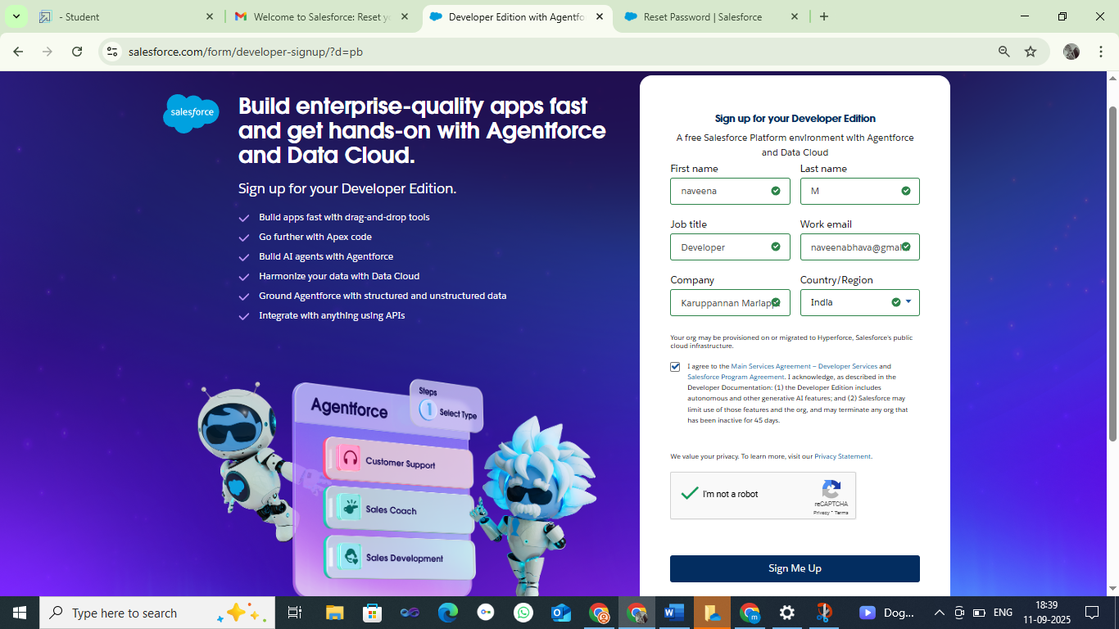

* OBJECT: Plural label

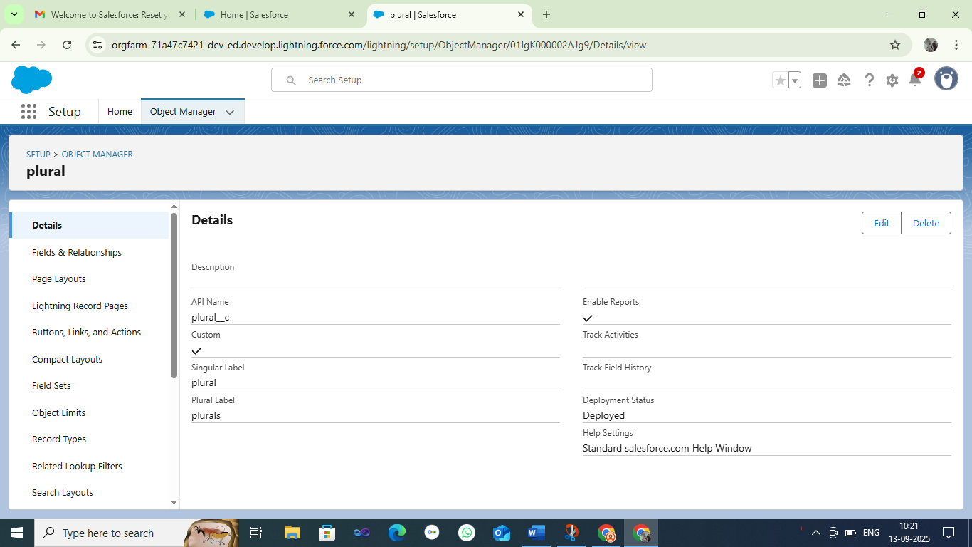

* OBJECT:Property Object,Tenant Object,Payment Object,Lease Object

# Property Object:

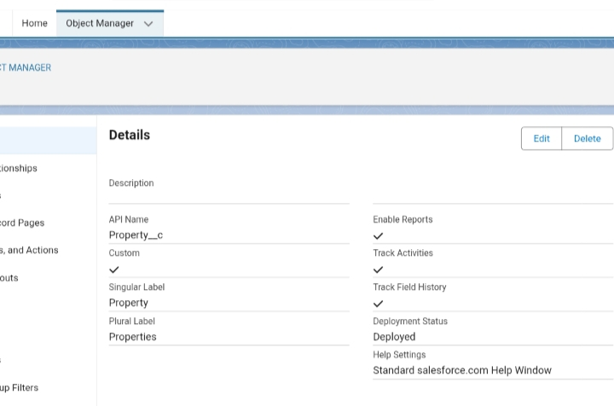

# Tenant Object:

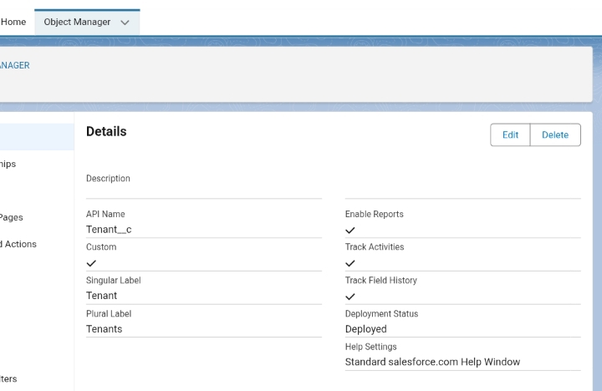

# Payment Object:

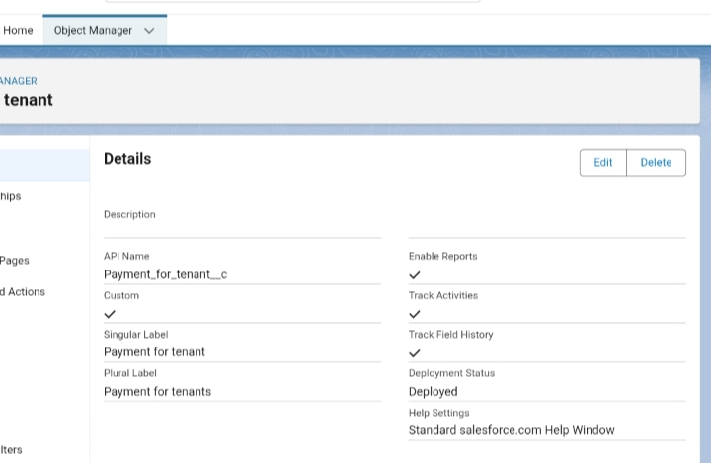

# Lease Object:

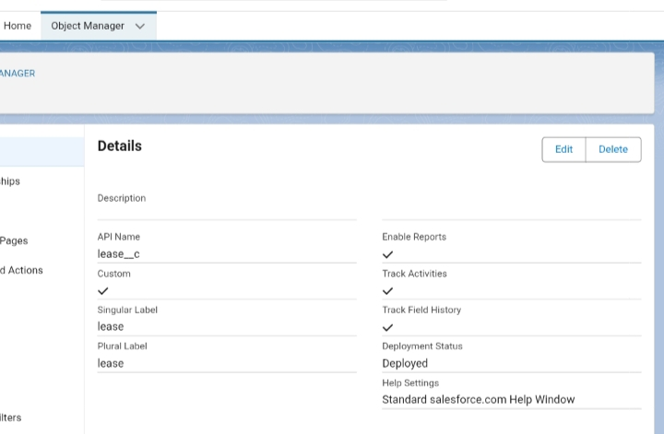

* Creating A Custom Tab

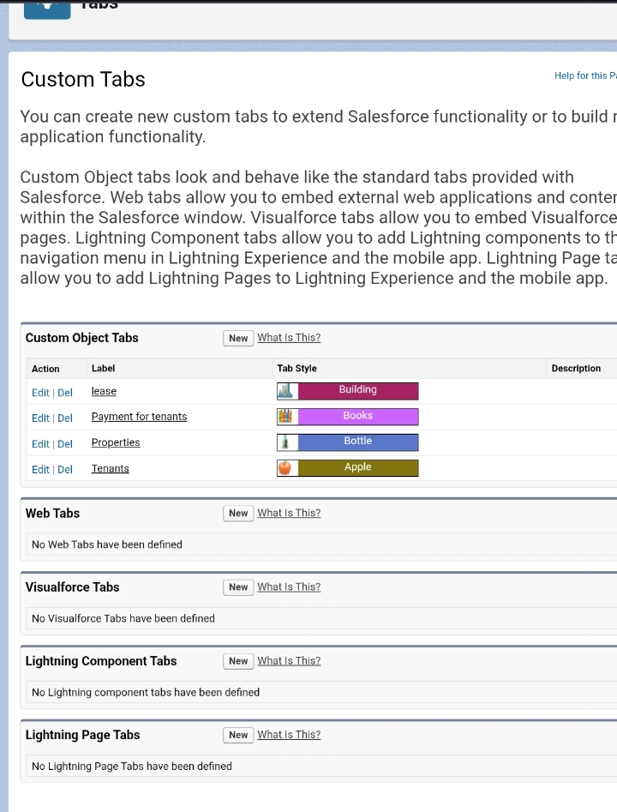

* The Lightning App

Create a Lightning App

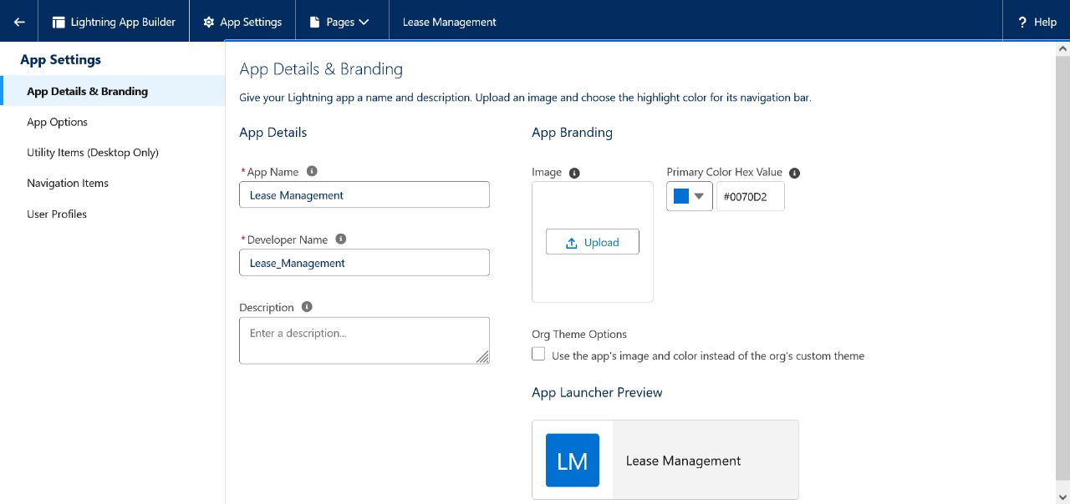

* Fields:

Creation of Relationship Fields in Objects

# Property Object:

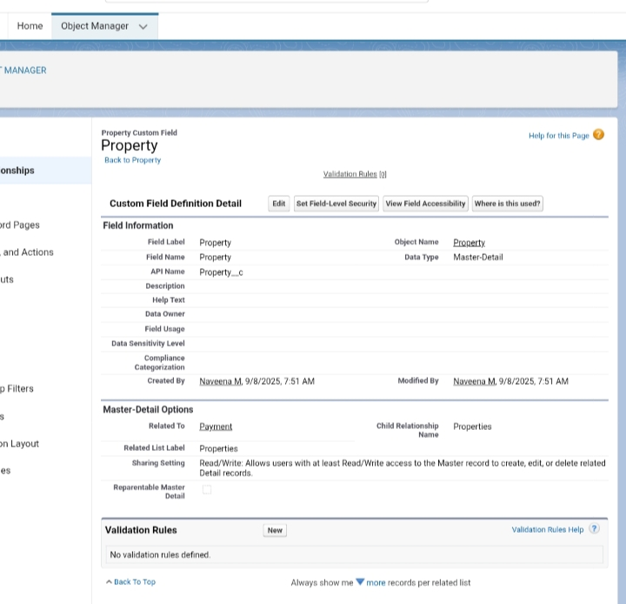

# Tenant Object:

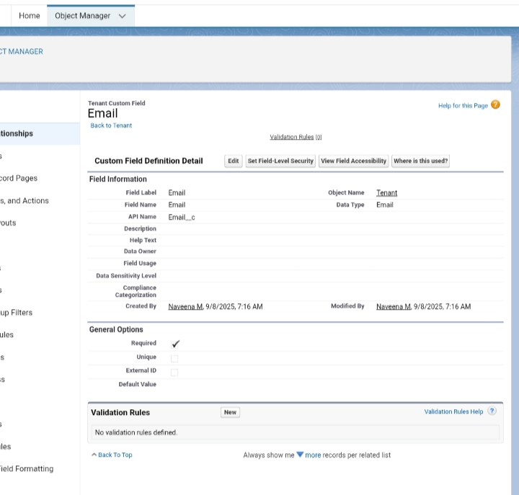

# Lease Object:

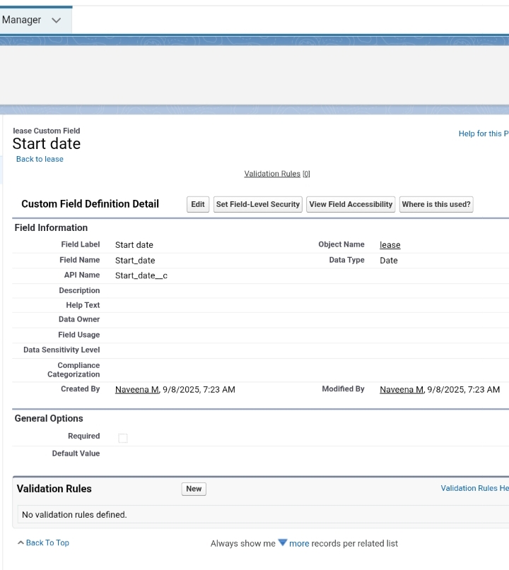

# Payment For Tenant Object:

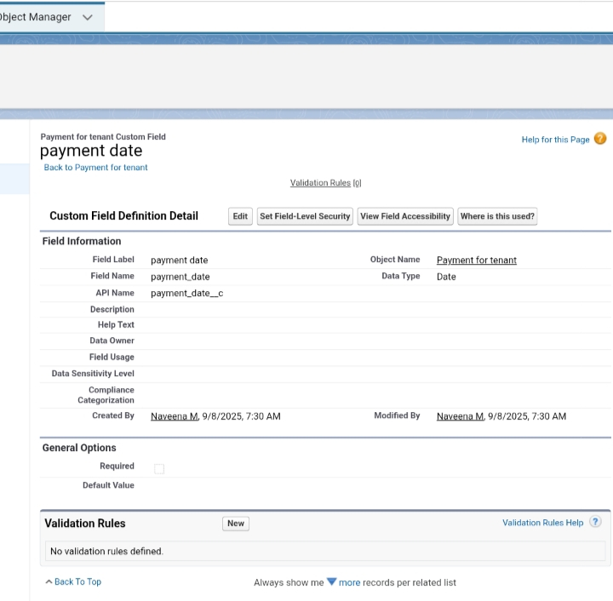

* Validation Rule:

# Create A Validation Rule To An Lease Object:

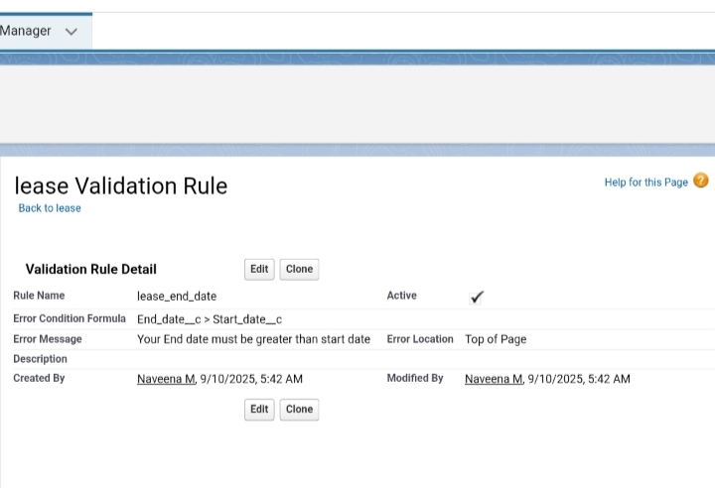

* Email Templates:

# Tenant Leaving:

* 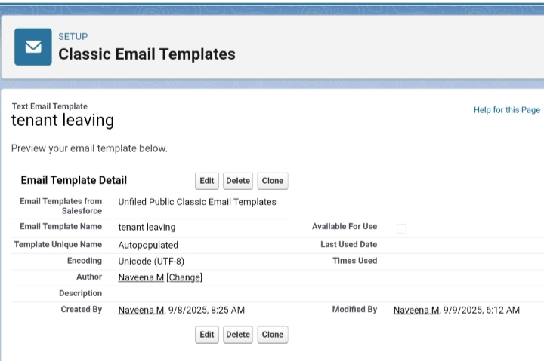

# Leave Approved:

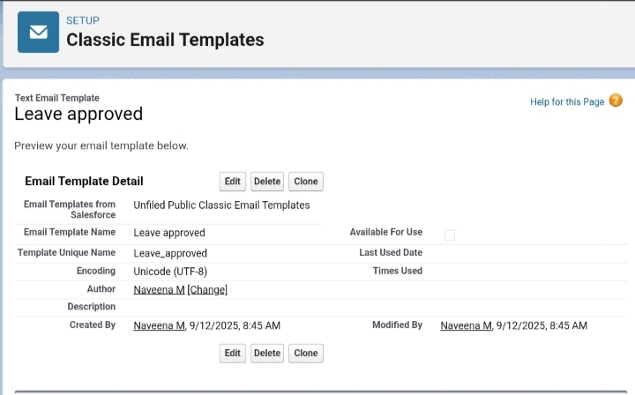

# Rejection For Leave:

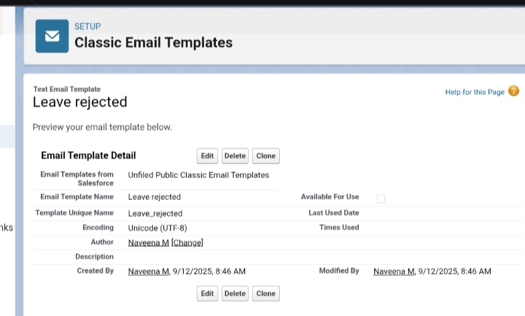

# Monthly Payment:

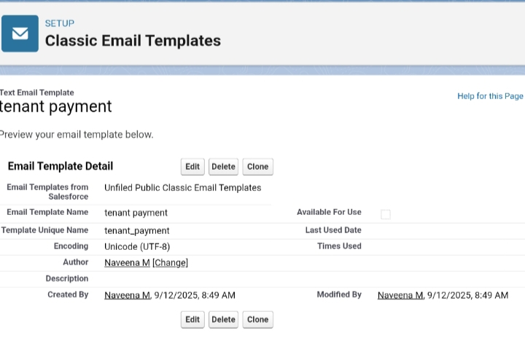

# Successful Payment:



* Approval Process:

Check For Vacant: 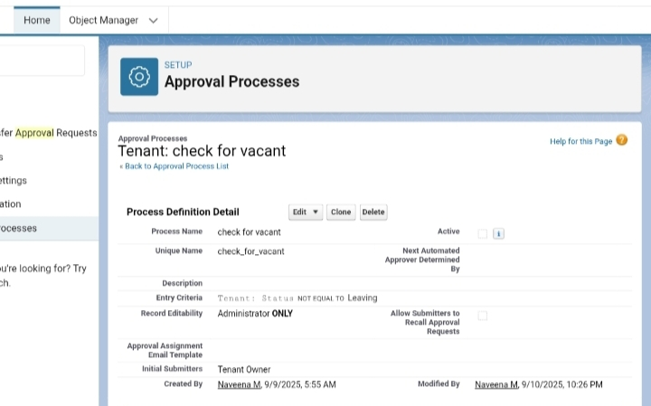

# Final Approval Action:

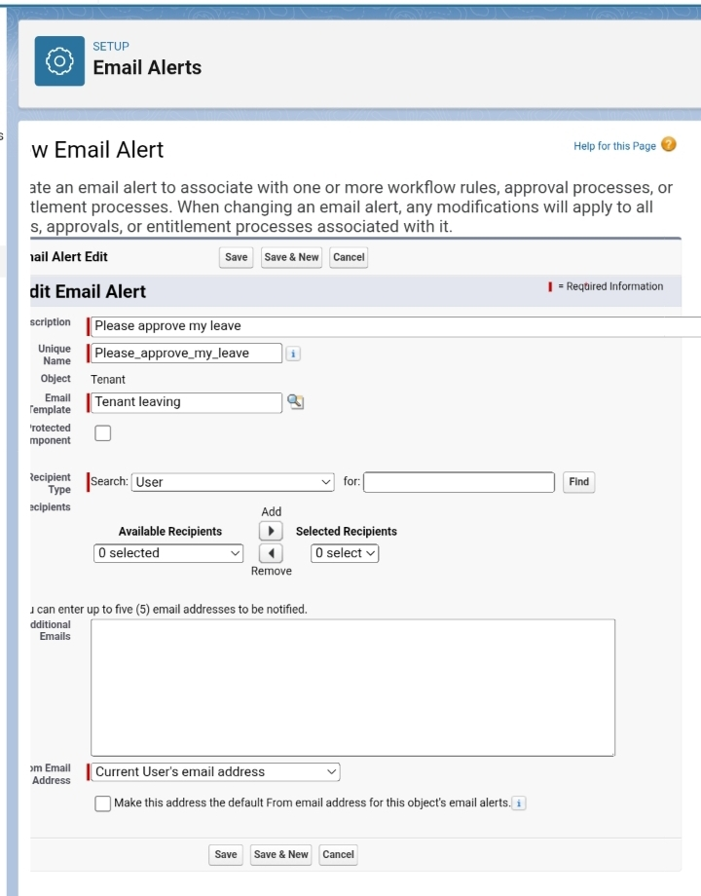

* Apex Trigger:

Create an apex trigger

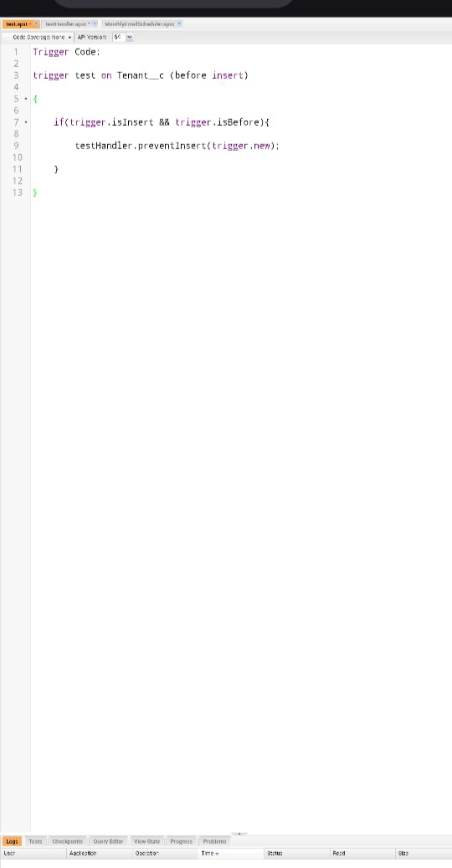

Create an apex handler class

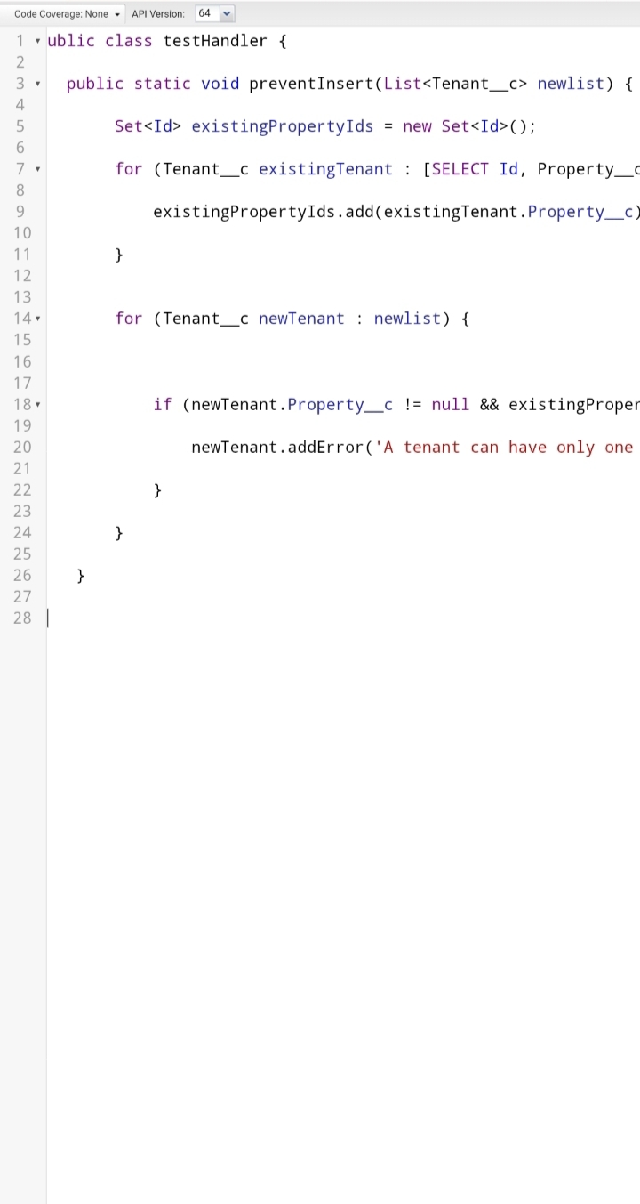Testing the trigger

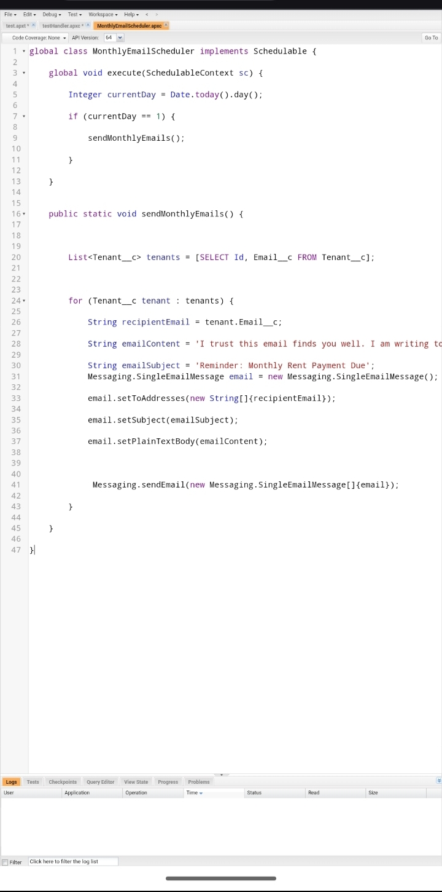

* Schedule Class:

Create an apex class



* ADVANTAGE:

1. Centralized Information Stores all lease agreements, documents, and key dates in one place. Reduces the risk of losing contracts or missing critical clauses.

2. Better Compliance & Risk Control Helps meet accounting standards (like IFRS 16 / ASC 842). Sends automatic alerts for renewals, rent escalations, and regulatory deadlines.

3. Cost Savings Tracks payments, late fees, and penalties to avoid unnecessary costs. Highlights opportunities to renegotiate terms or terminate unprofitable leases.

4. Improved Financial Planning Generates reports on rent obligations, future cash flow, and asset utilization. Supports accurate budgeting and forecasting.

* DISADVANTAGE:

1. High Initial Setup or implementation costs Purchasing or configuring lease-management software can be expensive. Data migration from legacy systems or spreadsheets takes time and money.

2. Complex Compliance Requirements Keeping up with changing accounting standards (e.g., IFRS 16, ASC 842) can be difficult. Errors in classification or reporting can lead to financial penalties.

3. Administrative Burden Collecting accurate data for every lease—dates, payments, maintenance details—requires ongoing effort. Poorly trained staff may create inconsistencies or duplication.

4. Dependence on Technology A system outage or cybersecurity breach can interrupt critical operations. Regular updates, backups, and IT support are essential.

* CONCULSION:

Lease management is more than simply tracking rental agreements—it is a strategic process that directly affects an organization’s finances, compliance, and operational efficiency.